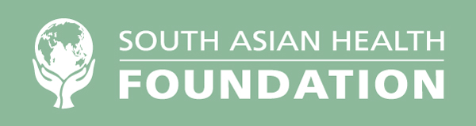

SOUTH ASIAN HEALTH FOUNDATION

MEDICAL ELECTIVE AWARD 2024

The South Asian Health Foundation, a UK charity whose aims are to improve the health and well-being of South Asians, is delighted to invite applications for a medical student elective bursary to the sum of £250

Submission Deadline: 1st January of year of bursary
Award Date: Decision will be made by February 1st by the SAHF Diabetes Working Group.
Prize: Two awards of £250
Open To: Medical Students

Please submit 250 words on the likely benefit of the elective and to explain why the SAHF should support the application. An application form must also be completed and returned with the 250-word submission.

Successful applicants will be required to provide written evidence of their visit (copies of receipts etc) and to provide a 1500-word report within 3 months of completion of the elective period, which is suitable for publication, on their visit once it has been completed. Please submit 2 copies of your application and CV (one with and one without your name and institution), and an application form.

Application Form

Administrative information

SAHF Medical Elective Award
Deadline for submission: January 1st of year of bursary

General Information

University/Institution:
Year of study / Grade:
Name and address of person to whom correspondence should be sent
Name:
Address:
Postcode:
Telephone:
Mobile:
Email address:

Bursary Information (if elective outside of UK)\

Country travelling to:
Address of proposed place of elective / training:

Date of proposed travel:

Hospital / School/ Institution attending whilst travelling:

Contact person supervising elective or training (if applicable) :

Additional information:

Budget

Subject of Elective

Amount Requested:

£

CHECKLISTS please check that you have enclosed:
- Additional information (250 word submission)
- Curriculum Vitae
- This form completed and signed

Applicant Signature

